**useState Hook**

* **What Is Hook ?**
* **What Is Usestate ?**
* **Primitive And Non Primitive States ?**
* **Asynchronous Nature Of Setstate ?**
* **Lazy Initialization ?**

Hooks:

Hooks in react are plain javascript functions.

Hooks can only be called inside another javascript function.

Every hook should start with ‘use’ prefix.

useState:

The useState hook in React is a fundamental tool for managing state within functional components. It allows functional components to "remember" values between re-renders, enabling them to be stateful.

we can not use state outside a function.

1.We declare use state like this:

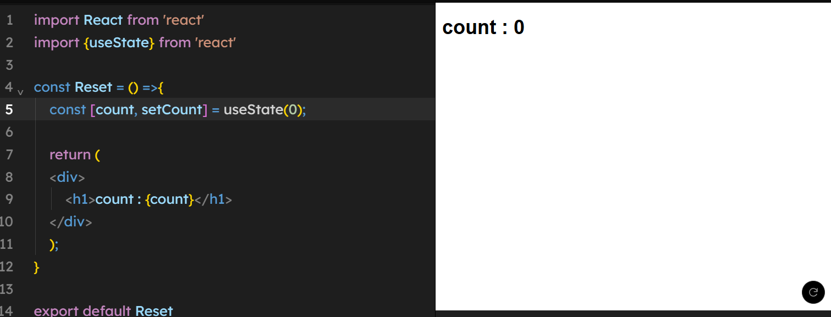

You can setup a react project like this with webpack:

Create public folder and inside create index.html file

Create a src folder and inside create a index.js and if you want css file

Run npm init to create package.json

Run npm I react react-dom to get modules or npm install

Create a webpack.config.js file with the code what are required

And install the dependencies which are in the webpack

Install the babel in your project

And run npx webpack

Run npx webpack server

The setup is completed and it will run on localhost server.

**Refer from** [**Git hub**](https://github.com/guvvalanaresh/react-course-practice) **from here onwards for every topic is created in a separate folder in github repository react-course-practice.**